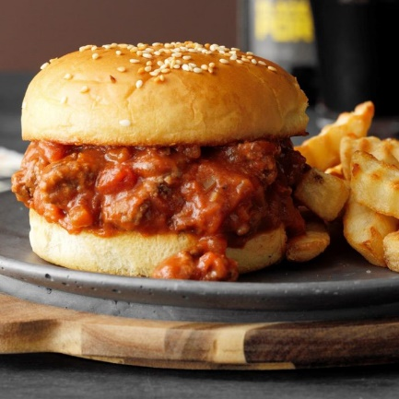
Easy Salsa Sloppy Joes
Prep Time None Cook Time 20 min
8 Sandwiches
Ingredients
1 lb ground beef
1 1/3 cups salsa
1 can (10 ¾ ounces) condensed tomato soup, undiluted
1 tablespoon brown sugar
8 hamburger buns
Directions
- In a large skillet, cook beef over medium heat until no longer pink. Drain.
- Stir in salsa, soup and brown sugar. Cover and simmer 10 minutes or until heated through.
- Serve on buns.

